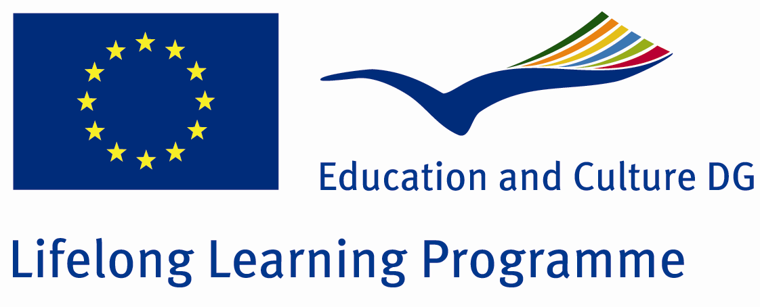

TRAINING AGREEMENT and QUALITY COMMITMENT LEONARDO DA VINCI PROGRAMME

I. DETAILS ON THE PARTICIPANT
Name of the participant: Dr Alexandra Turi
Field of vocational education: neonatal intensive care
Sending institution (name, address): Semmelweis University 2nd Department of Paediatrics
Hungary, Tűzoltó Street 7-9., Budapest 1094
Contact person (name, function, e-mail, tel): F. Tóth Katalin, coordinator, ftoth.katalin@semmelweis-univ.hu, (0036) 1 4591491

II. DETAILS OF THE PROPOSED TRAINING PROGRAMME ABROAD
Receiving organisation (name, address): The Leeds Teaching Hospitals, Great George Street, Leeds, West Yorkshire, LS1 3EX, , England

Contact Person (name, function, e-mail, tel, fax): Dr Sharon English, Lead Clinician Neonatal Service
Sharon.english@leedsth.nhs.uk, tel: 0113 3928537, fax: 0113 3926068

Planned dates of start and end of the placement period: 2014.01.01 – 2014.03.31.

- Knowledge, skills and competence to be acquired:
- The anticipation and recognition of complications prematurity
- The assessment and diagnosis of the neonate with congenital abnormalies
- Choosing the most appropriate treatment for neonates with perinatal infection
- The stabilization of neonates of various gestational ages upon presentation
- Managing cardiovascular emergency cases of neonates
- The anticipation and recognition of neonatal effects of maternal disease processes and conditions
- Local innovations in diagnostic and therapeutic methods, such as diagnosing and monitoring complex congenital abnormalies in the womb

- Detailed programme of the training period:
- 12 weeks of work experience at the neonatal intensive care unit

- Tasks of the trainee:
- Taking part in the work of a specialist center that provides all levels of care for neonates
- Taking part in a wide-ranging multidisciplinary team
- Taking part in the daily routine of the department and helping the daily work of the staff
- Learning and practising invasive intervention in neonates such as umbilical artery catheterization
- Observing/assisting in echocardiographic and ultrasound examinations in neonates

- Monitoring and Mentoring of the participant:
- Home tutor revises work plan, host mentor provides daily supervision and consultation possibilities.
- Participant writes up a daily training log which is supervised and countersigned by the host mentor.
- Evaluation and Validation of the training placement:
- Evaluation and completion certificate will be issued by Mentor at the end of the training period.

III. COMMITMENT OF THE THREE PARTIES

By signing this document, the participant, the sending institution and the receiving organisation confirm that they will abide by the principles of the Quality Commitment for Leonardo da Vinci training placements attached below.

THE PARTICIPANT
Participant’s signature
........................................................................... Date:

THE SENDING INSTITUTION
We confirm that this proposed training programme agreement is approved.
On completion of the placement the sending institution will acknowledge the training as part of the postgraduate vocational education programme of the participant, based on the preliminary approval of the person(s) responsible for the postgraduate education of the participant.
Coordinator’s signature  ............................................................................. | Date: ...................................................................

THE RECEIVING ORGANISATION
We confirm that this proposed training programme is approved.
On completion of the training programme the organisation will issue a “Certificate of Completion” to the participant
Coordinator’s signature  Dr Sharon English  Lead Clinician Neonatal Services | Date: 27/09/2013

